DATE:11-11-23

**NAVKIS COLLAGE OF ENGINEERING**

FOOTPRINTING REPORT ON

Linkedin.com

**HEMANTHA KUMARA E K**

**YEAR: SECOND YEAR**

**BRANCH: CSE**

**SEC:’B’**

**USN:4YG18CS010**

**NICC ID: NCE23S0087**

**FOOTPRINTING**

**FOOTPRINTING/RECONAISSANCE:**IS A FIRST PHASE OF HACKING WHERE WE TRY TO GATHER AS MUCH AS INFORMATION ABOUT THE TAREGT.

* FIRSTLY WE CHECK THE GIVEN TARGET IS SECURED OR NOT.
* WE CAN FINDOUT OUR TARGET IP ADDRESS BY USING PING COMMAND.

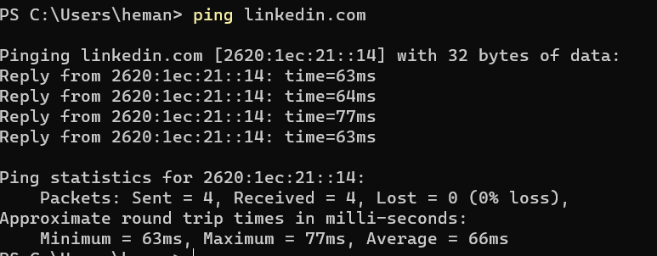

HERE WE CAN FINDOUT IP ADDRESS OF THE TARGET AND KNOW HOW MUCH TIME TAKEN TO REACH THE TARGET AND GET THE RESULT OF THE TARGET.IT TAKES AVERAGE 66MS TO REACH TARGET AND GET BACK.



* WE CAN USE TRACEROUTE ALSO TO FIND OUT THE IP ADDRESS AND TO KNOW HOW MANY ROUTERS ARE BETWEEN TARGET.

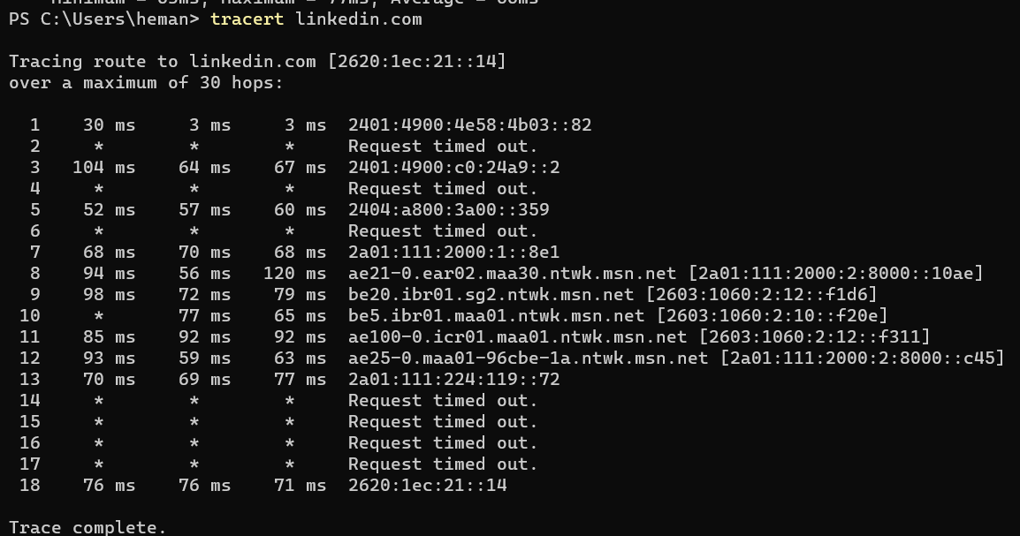

HERE BETWEEN THE TARGET THER ARE 17 ROUTERS ARE THERE BETWEEN 1-17 IP ADDRESSES ARE THE ROUTER IP ADDRESSES AND 18TH IP ADDRESS IS THE TARGET IP ADDRESS.

* WE CAN FIND OUT THE IP ADDRESS BY USING ‘NSLOOKUP’ COMMAND ALSO IT SHOWS NAME AND IP ADDRESS OF THE DOMAIN.

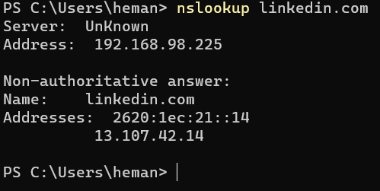

* BY MORE INFORMATION ABOUT THE TARGET WE SEARCH NETCRAFT.COM. AND SEARCH FOR SITE INFORMATION IT SHOWS ALL DETAILS RELATED TO THE TARGET.

EX: SITE TITLE, SITE RANK, LANGUAGE, DOMAIN NAME, IPV 4 AND IPV 6 ADDRESSHOSTING COMPANY,HOSTING COUNTRY AND ALL.

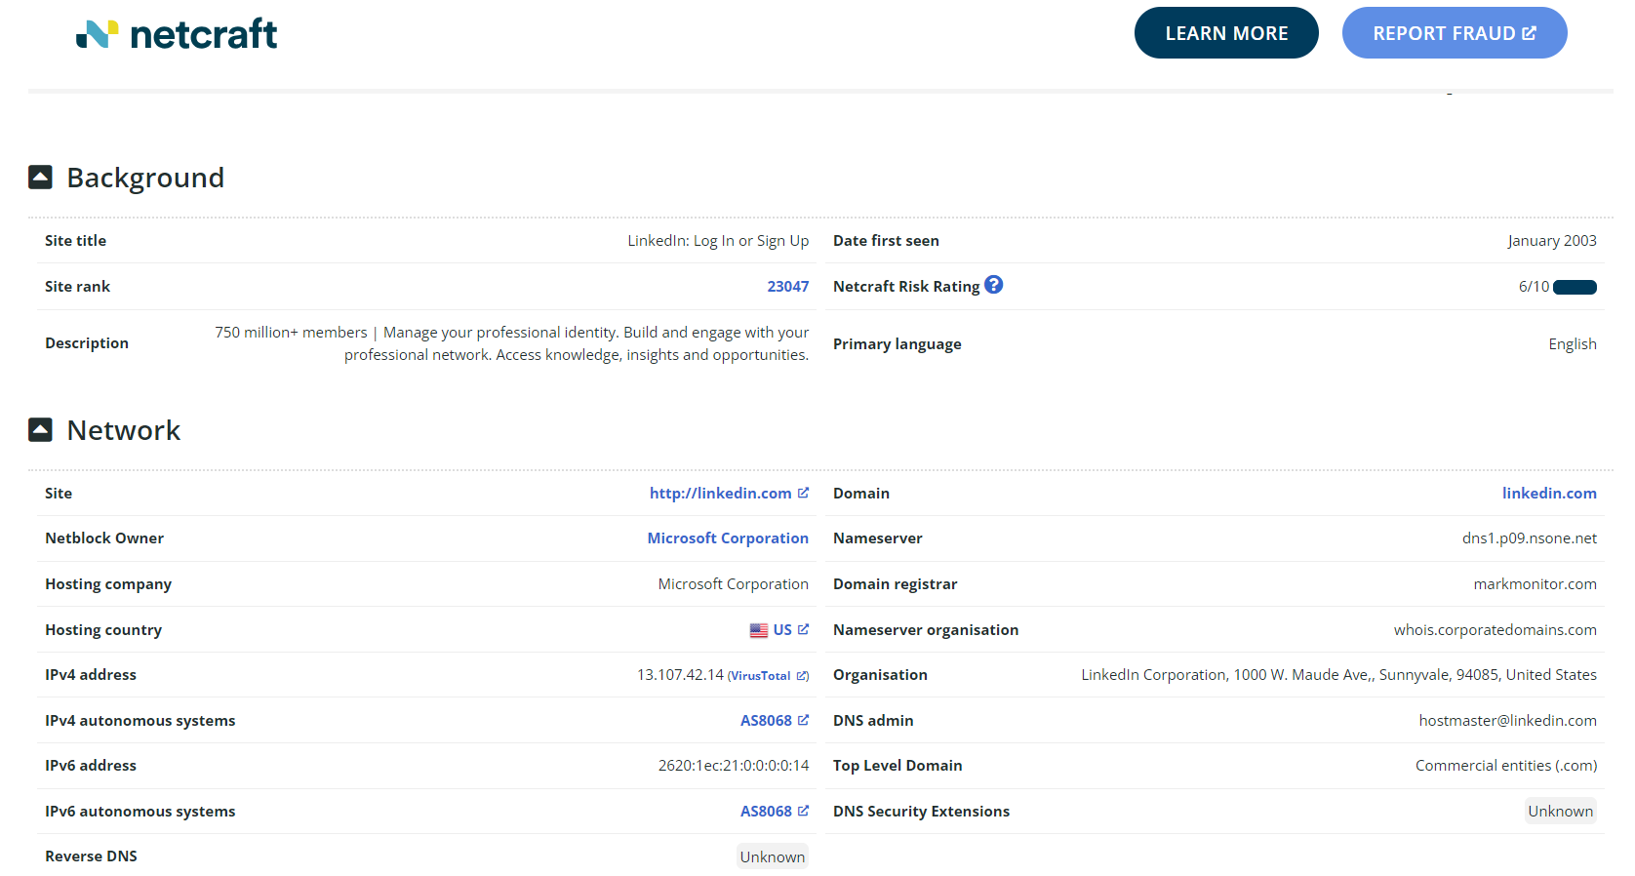

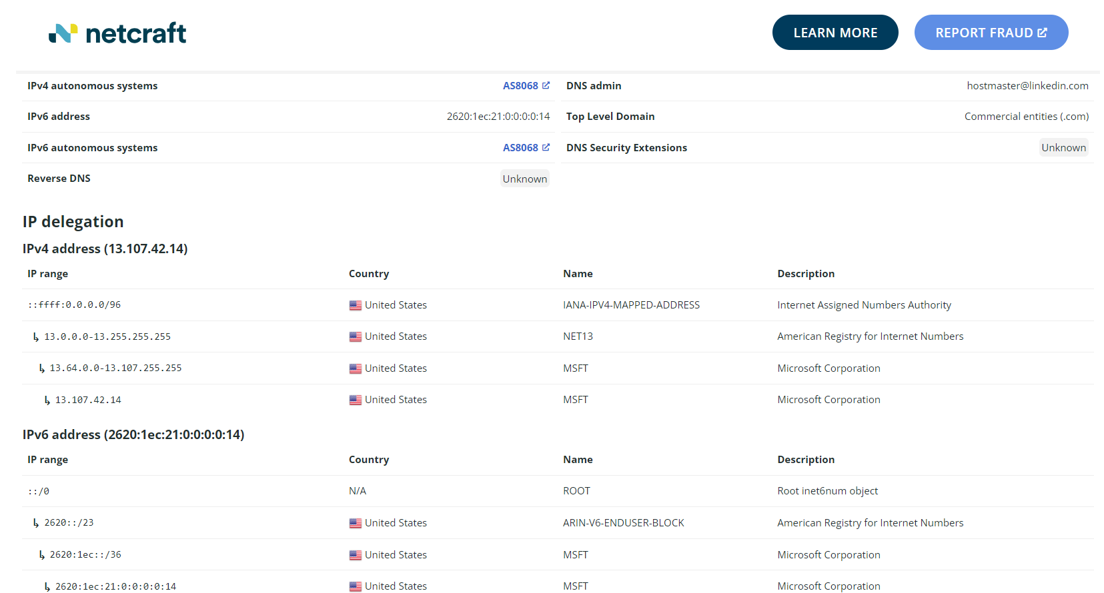

AND WE CAN FINDOUT SITE TECHNOLOGIES IN MY TARGET WEBSITE THEY USING SERVER SITE LANGUAGE AS JAVA SERVLET, CLIENT SIDE THEY USE JAVASCRIPT AND FRAME IS HTML5.

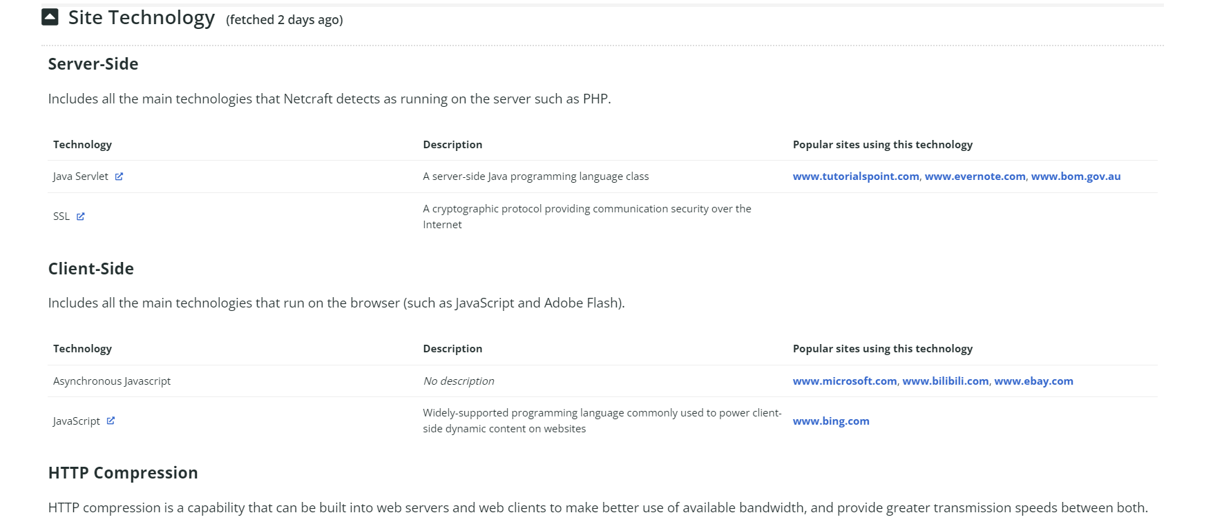

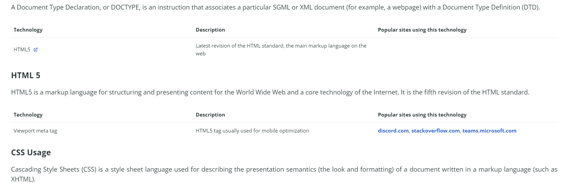

* WE CAN FINDOUT THE OPEN PORT IN TARGET BY USING CENSYS.IO , IT SHOWS THE WHICH PORTS ARE OPEND IN A TARGET ,WHICH OS THERE ARE USE ,COUNTRY AND REVERSE AND FORWARD DNS.

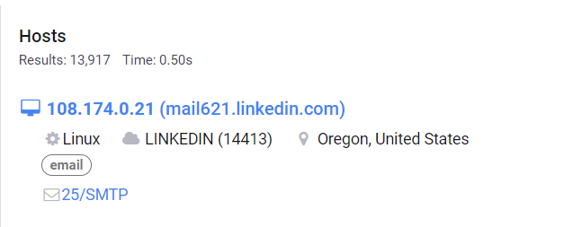

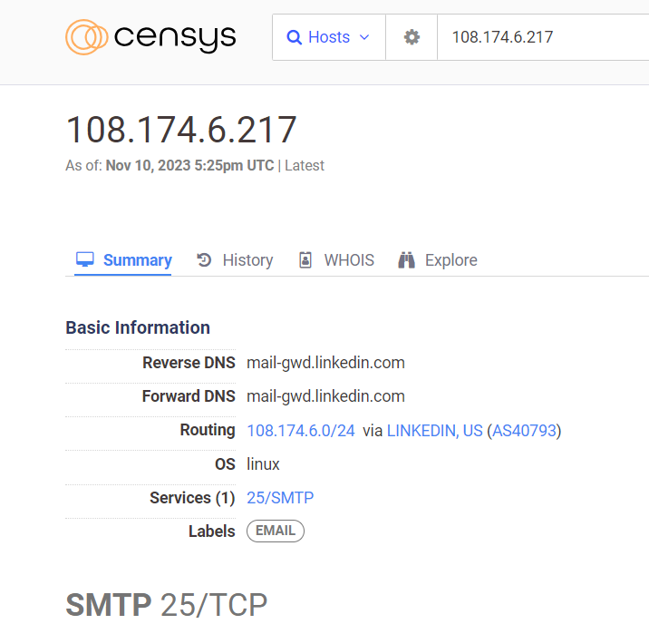

* WE CAN FIND OUT DNS RECORDS OF THE WEBSITE BY USING DNS LOOKUP.

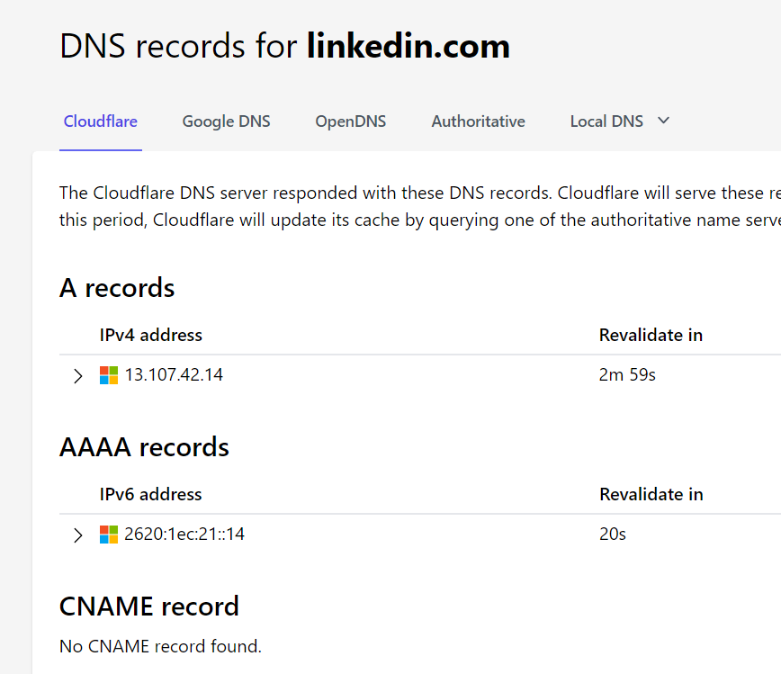

* CHECK OUT THE WHAT ARE DIFFECT PRESENT IN THE TARGET AND RESEARCH AGAINST THE DIFECT. HERE REFERENCE POLICY AND PERMISION POLICY ISSUES ARE THERE.

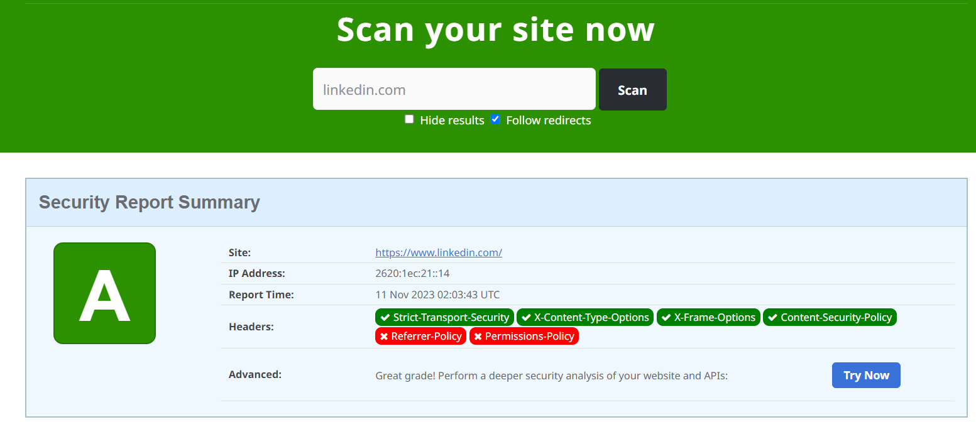

* BY USING HUNTER.IO WEBSITE TO FINDOUT THE E-MAIL ADDRESS OF TARGETED COMPANY EMPLOYEES IT HELPS TO ACCESS DATA. 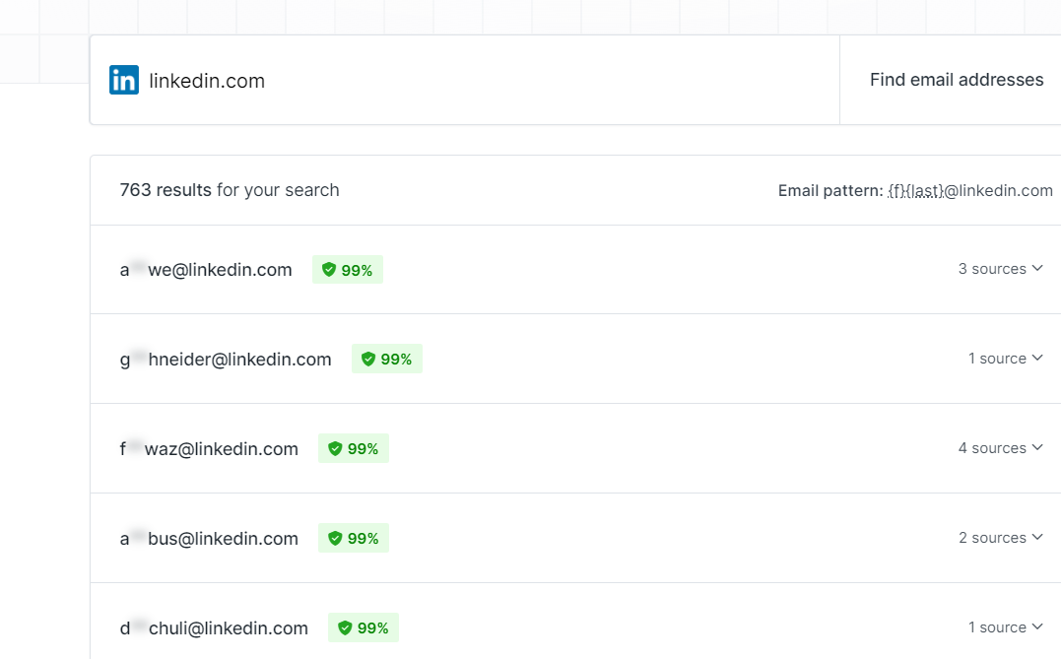
* BY USING DIG COMMAND WE CAN FINDOUT UDP,FLAGS ,IP AND DNS COUNTRY DATA.

